

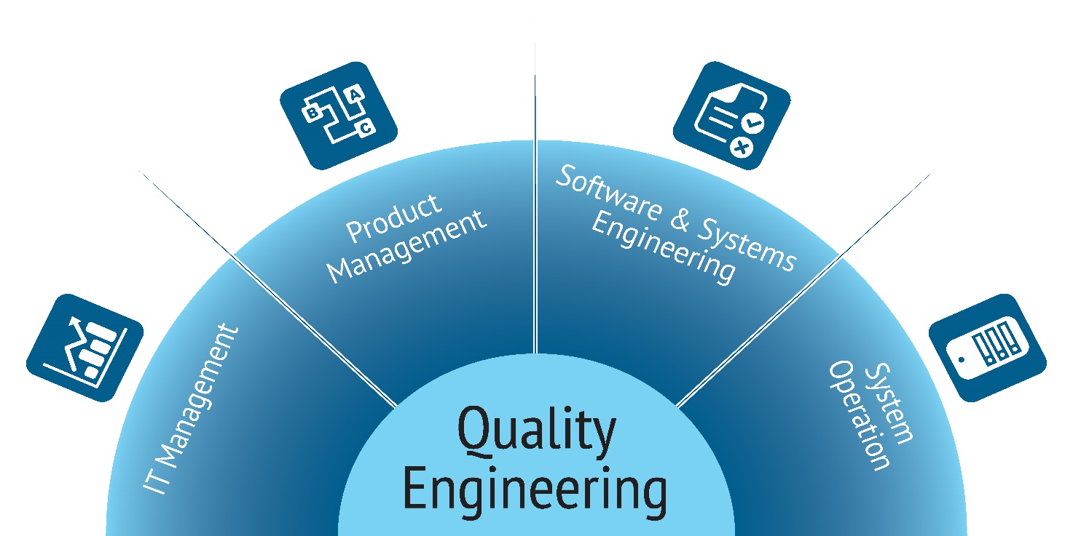

ENGINEERING

An engineer applies scientific and mathematical principles to design, develop, and maintain systems, structures, and processes across various industries. Engineers can specialize in diverse fields such as civil engineering, electrical engineering, mechanical engineering, aerospace engineering, and many others. They are responsible for conceptualizing, planning, and executing projects, ensuring they meet safety standards, regulatory requirements, and are economically viable

An engineer applies scientific and mathematical principles to design, develop, and maintain systems, structures, and processes across various industries. Engineers can specialize in diverse fields such as civil engineering, electrical engineering, mechanical engineering, aerospace engineering, and many others. They are responsible for conceptualizing, planning, and executing projects, ensuring they meet safety standards, regulatory requirements, and are economically viable.

MECHANICAL ENGINEER

**Mechanical engineering** is the study of physical machines that may involve force and movement. It is an engineering branch that combines engineering physics and mathematics principles with materials science, to design, analyze, manufacture, and maintain mechanical systems. It is one of the oldest and broadest of the engineering branches.



CEMICAL ENGINEERING

**Chemical engineering** is an engineering field which deals with the study of operation and design of chemical plants as well as methods of improving production. Chemical engineers develop economical commercial processes to convert raw materials into useful products. Chemical engineering uses principles of chemistry, physics, mathematics, biology, and economics to efficiently use, produce, design, transport and transform energy and materials. The work of chemical engineers can range from the utilization of nanotechnology and nanomaterials in the laboratory to large-scale industrial processes that convert chemicals, raw materials, living cells, microorganisms, and energy into useful forms and products. Chemical engineers are involved in many aspects of plant design and operation, including safety and hazard assessments, process design and analysis, modeling, control engineering, chemical reaction engineering, nuclear engineering, biological engineering, construction specification, and operating instructions.



ENVIROMENTAL ENGINEERING



An environmental engineer applies principles of engineering, chemistry, biology, and geology to address environmental challenges and promote sustainable solutions. These engineers work on projects that aim to protect and enhance the environment, managing issues such as air and water pollution, waste management, and the impact of human activities on ecosystems.

Environmental engineers design and implement technologies to mitigate environmental impacts, conduct environmental assessments, and develop strategies for sustainable resource management, contributing to the overall well-being of both human populations and the natural world.

Aerospace engineers work to develop things that fly-airplanes, spacecraft, missiles, and so on. They do so by incorporating physics principles such as lift, drag, and thrust. The products that they develop help to defend us from threatening nations and help us go where we need to go, whether that’s a vacation to Greece or a space flight to Mars.

ENGINEER AEROSPACE

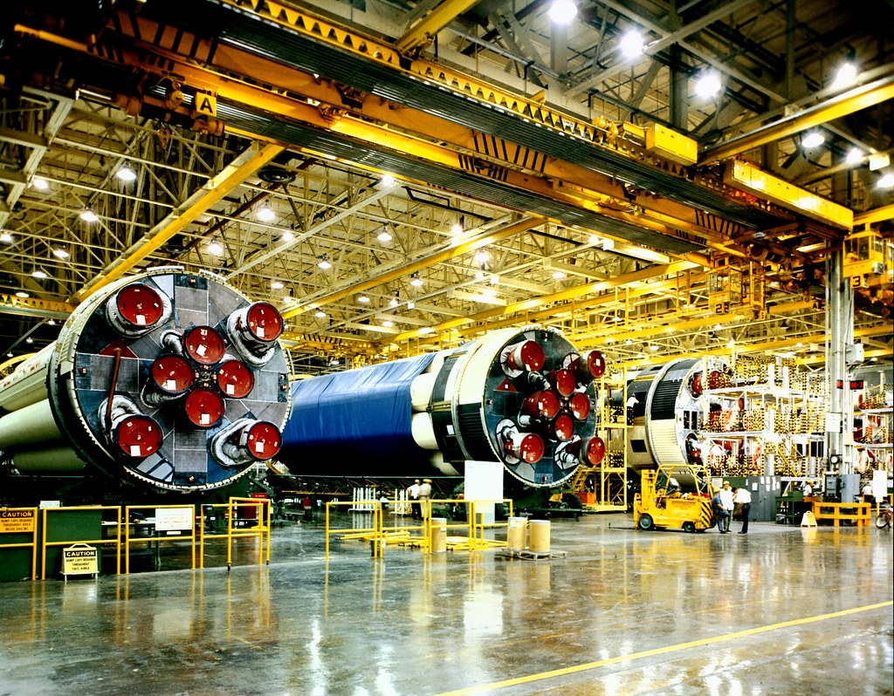

AGRICULTURE & FOOD ENGINEER

These engineers are all about food, not unlike myself. Except I just eat it. Food engineers help design systems for producing, storing, and distributing it. They are responsible for ensuring that we can continually produce enough food to feed our growing populations and that the food is stored in a safe and efficient manner. Without them, we would likely have to deal with food shortages on a regular basis.

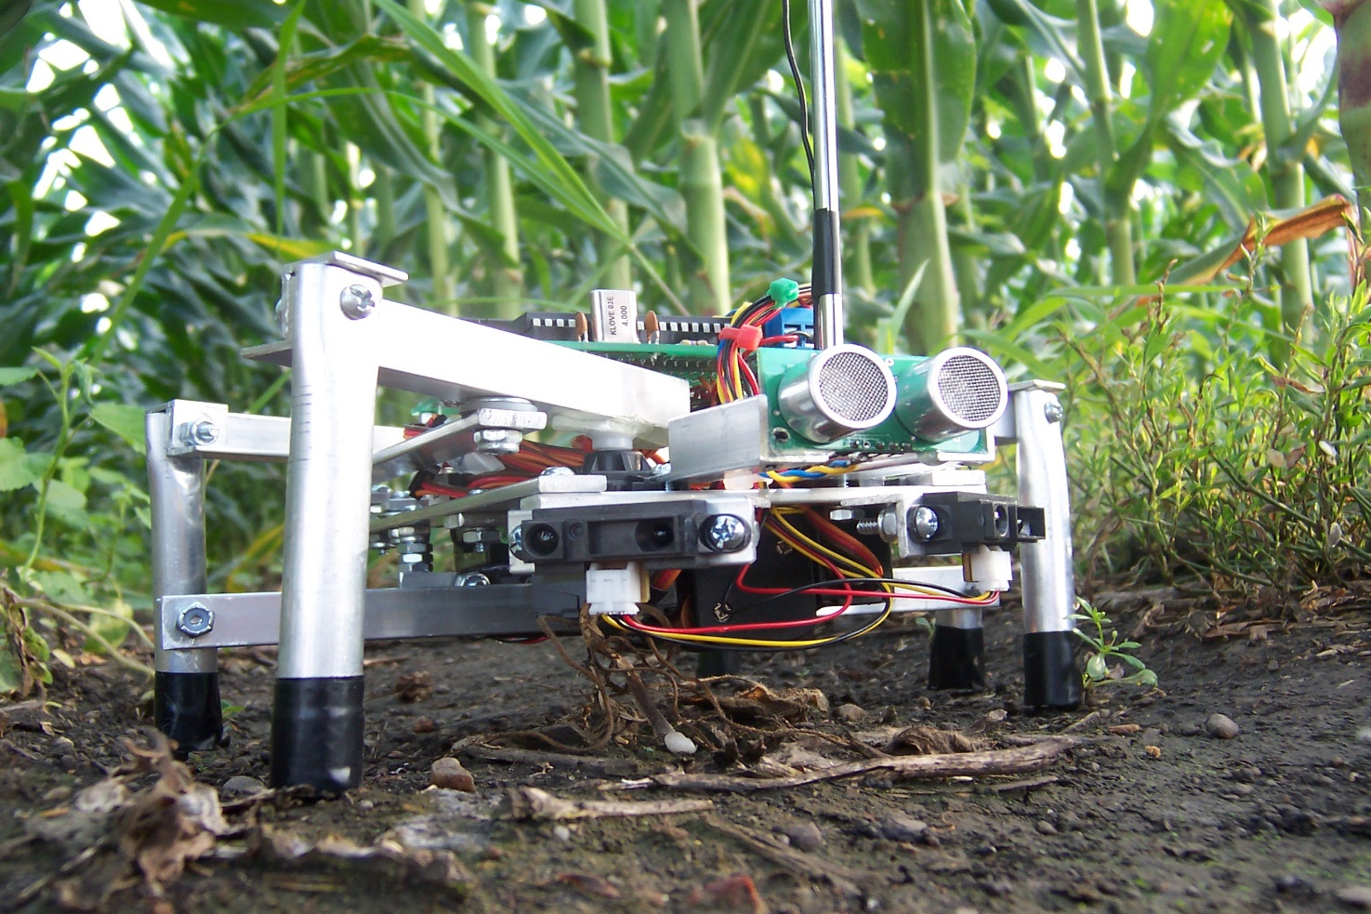

*Automotive engineers design the cars, trucks, SUV’s, and vans that you and I drive on a daily basis. They use their knowledge of things like aerodynamics, material densities, and even software and electronics applications to design everything from the physical shapes of cars to their complicated electrical systems. If we didn’t have automotive engineers, getting around would be not only much slower but also much more difficult.*

AUTOMOTIVE ENGINEER

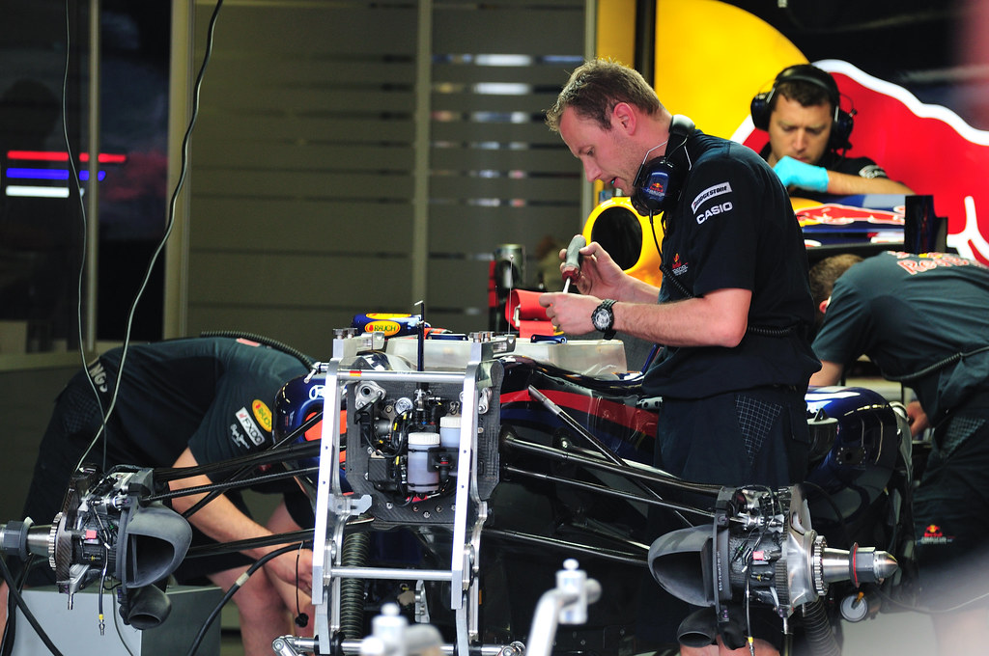

If you’ve ever been to a hospital, you’ve seen the work of this group. Biomedical engineers are the ones who design the devices and instrumentation used in the healthcare industry. Everything from prosthetic limbs to CPAP machines have been developed by biomedical engineers. They build the machines and other devices that help save our lives, deliver our babies, and sometimes just live a little more comfortably.

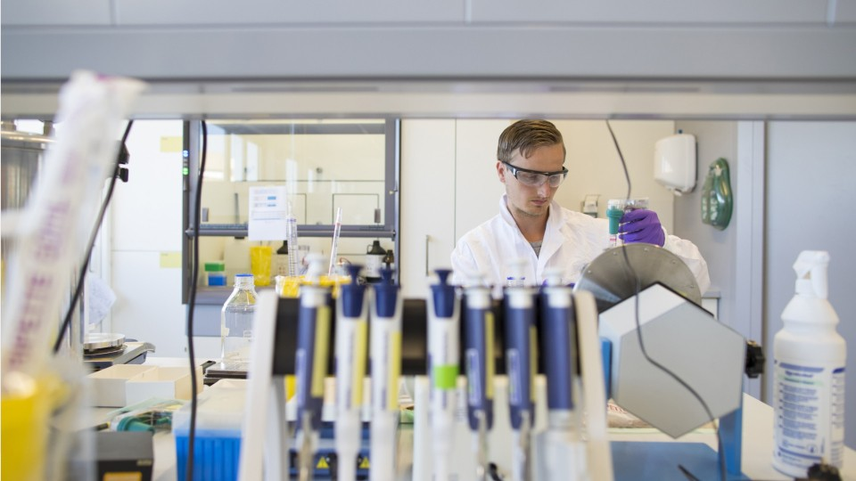

BIOMEDICAL ENGINEER

Computer engineers don’t only design home computers. They also develop mobile devices, embedded computer systems for industrial processing, computer peripherals like keyboards and printers, machine learning and artificial intelligence programs, and much more. For better or worse, we would never have reached the digital age without computer engineers.



COMPUTER ENGINEER

Many nations around the world are incorporating nuclear energy into their national energy programs. The nuclear reactors that play a crucial role in producing nuclear energy are designed and built by nuclear engineers. They are tasked with ensuring the reactors are safe, not only for the people who work there but also for the people who live in the surrounding areas.

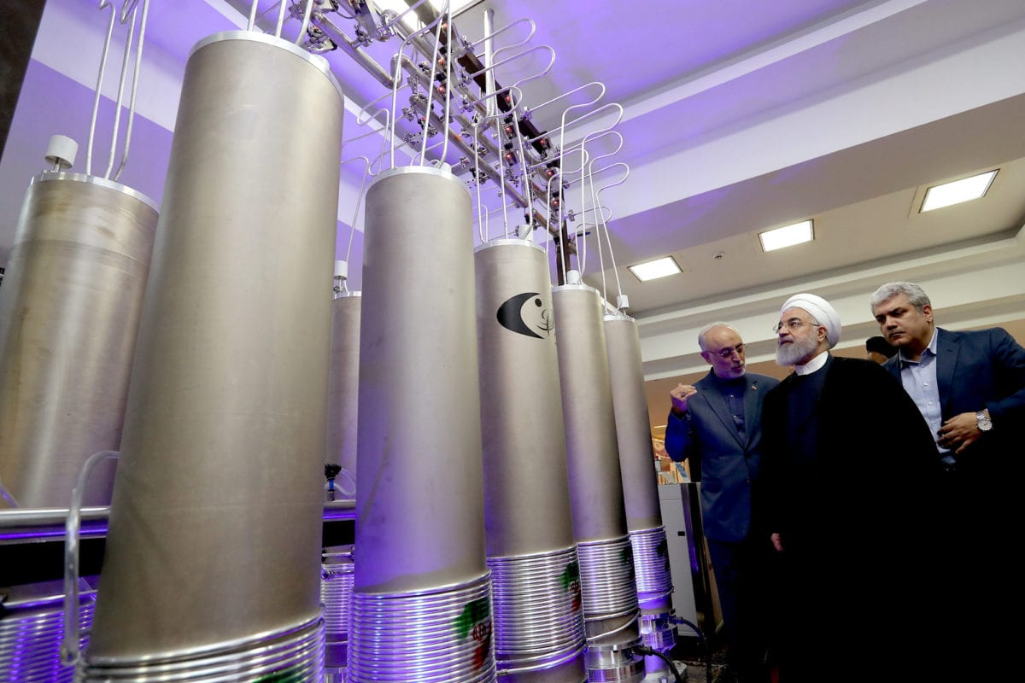

NUCLEAR ENGINEER

Civil engineer

The neglected step-children of engineers, civil engineers design some of the most important systems. They design systems to supply people with clean water as well as systems to clean it back up after use. They also design things like roads, bridges, dams, etc. Without civil engineers, we would still be walking through the woods to a nearby river to get water.



ELECTRICAL AND INSTRUMENTATION ENGINEER

Electrical and instrumentation engineers develop machines and equipment that are used in manufacturing, vehicles, research, etc. Most of the other engineers on this list rely in some way on instrumentation that’s designed by an instrumentation engineer. They develop the instruments that help pilots fly and allow doctors and nurses to monitor your vital signs.

